Data Structures Laboratory
Assignment-3

ListADT and its Applications – Doubly linked lists
Name: Sai Shashaank R
Register No: 205001086
Class: CSE-B
adt.h
struct listADT
{
char item;
struct listADT *next;
struct listADT *prev;
};

void insertFront(struct listADT *l, char c);
void insertEnd(struct listADT *l, char c);
void insertMiddle(struct listADT *l,char c,char d);
void displayItems(struct listADT *l);
void deleteItem(struct listADT *l,char c);
int searchItem(struct listADT *l,char c);

/*-----Extra functions----------*/
void init (struct listADT *l); //To initialise the header of a list
int listCompare(struct listADT *l1,struct listADT *l2); //To compare two doubly linked lists
void input(struct listADT *l); //To take input for the doubly linked list

impl.h
#include "adt.h"
#include <stdio.h>
#include <stdlib.h>

void init(struct listADT *l)
{
l->next = NULL;
l->prev = NULL;
}

void insertFront(struct listADT *l,char c)
{
struct listADT *temp = (struct listADT *) malloc(sizeof(struct listADT));
temp->item = c;
temp->next = l->next;

if(l->next != NULL)
l->next->prev = temp;

l->next = temp;
temp->prev = l;
}

void insertEnd(struct listADT *l, char c)
{
struct listADT *temp = (struct listADT *) malloc(sizeof(struct listADT));

temp->item = c;
temp->next = NULL;

if(l->next == NULL)
{
l->next = temp;
temp->prev = l;
}

else
{
struct listADT *ptr = l;
while(ptr->next!=NULL)
ptr = ptr->next;

ptr->next = temp;
temp->prev = ptr;
}
}

void insertMiddle(struct listADT *l,char c,char d)
{
int flag = 0;
struct listADT *ptr = l->next;

while(ptr!=NULL)
{
if(ptr->item == c)
{
flag = 1;
break;
}

ptr = ptr->next;
}

if(flag == 1)
{
struct listADT *temp = (struct listADT *) malloc(sizeof(struct listADT));
temp->item = d;
temp ->next = ptr->next;

if(ptr->next != NULL)
ptr->next->prev = temp;

ptr->next = temp;
temp->prev = ptr;
printf("\nElement has been inserted.");
}

else
printf("\nERROR: Element not found.");
}

void displayItems(struct listADT *l)
{
if(l->next == NULL)
printf("\nList is empty.");

else
{
struct listADT *ptr = l->next;
while(ptr!=NULL)
{
printf("%c",ptr->item);
ptr=ptr->next;
}
}
}

void deleteItem(struct listADT *l,char c)
{
int flag = 0;
struct listADT *ptr = l->next;

while(ptr!=NULL)
{
if(ptr->item == c)
{
flag = 1;
break;
}

ptr = ptr->next;
}

if(flag == 1)
{
ptr->prev->next = ptr->next;
if(ptr->next != NULL)
ptr->next->prev = ptr->prev;

printf("%c has been deleted successfully!",ptr->item);
free(ptr);
}

else
printf("\nItem wasn't found.");
}

int searchItem(struct listADT *l,char c)
{
int counter = 0;
struct listADT *ptr = l->next;

while(ptr!=NULL)
{
if(ptr->item == c)
counter++;

ptr = ptr->next;
}

return counter;
}

int listCompare(struct listADT *l1,struct listADT *l2)
{
int flag = 0;

struct listADT *p1 = l1->next;
struct listADT *p2 = l2->next;

while(p1!=NULL && p2!=NULL)
{
if(p1->item != p2->item)
{
flag = 1;
break;
}

p1 = p1->next;
p2 = p2->next;
}

if(p1 != NULL)
flag = 1;

else if(p2 != NULL)
flag = 1;

return flag;
}

void input(struct listADT *l)
{
char str[50];
printf("\nEnter the string: ");
scanf(" %s",str);
for(int i=0; str[i]!='\0'; i++)
{
insertEnd(l,str[i]);
}
}

appl.c
#include "impl.h"

void main()
{
struct listADT *l;

char option;
int choice;
int k;

struct listADT *ptr;

struct listADT *temp;

/*To store consonants*/
struct listADT *c;
c = (struct listADT *)malloc(sizeof(struct listADT));
init(c);

/*To store vowels*/
struct listADT *v;
v = (struct listADT *)malloc(sizeof(struct listADT));
init(v);

do
{
l = (struct listADT *)malloc(sizeof(struct listADT));
init(l);
input(l); //Taking input for l

printf("\n1) Check whether the list is palindrome or not.");
printf("\n2) Create separate lists containing vowels and consonants from the list.");
printf("\n3) Swap kth node from the beginning with kth node from the end.");
printf("\n4) Number of times a letter occurrs in a list.");
printf("\n5) Insert a character in the middle.");
printf("\n6) Delete a character.");
printf("\n7) Exit.");
printf("\nEnter your choice: ");
scanf("%d",&choice);

switch(choice)
{
case 1: ptr = l->next;
temp = (struct listADT *)malloc(sizeof(struct listADT));
init(temp);

while(ptr!=NULL)
{
insertFront(temp,ptr->item);
ptr = ptr->next;
}

if(listCompare(temp,l)==0)
{
printf("\n\n");
displayItems(l);
printf(" is a palindrome.");
}

else
{
printf("\n");
displayItems(l);
printf(" is NOT a palindrome.");
}
break;

case 2: ptr = l->next;
while(ptr!=NULL)
{
if(ptr->item == 'A' || ptr->item == 'E' || ptr->item == 'I' || ptr->item == 'O' || ptr->item == 'U' )
insertEnd(v,ptr->item);

else
insertEnd(c,ptr->item);

ptr = ptr->next;
}

printf("\nVowels: ");
displayItems(v);

printf("\nConsonants: ");
displayItems(c);
break;

case 3: printf("\nEnter the value of k: ");
scanf("%d",&k);

int counter = 1;
struct listADT *pstart, *pend;

pend = l->next;
pstart = l->next;

while(pend->next!=NULL)
pend = pend->next;

while(counter != k)
{
pstart = pstart->next;
pend = pend->prev;
counter++;
}

char temp = pstart->item;
pstart->item = pend->item;
pend->item = temp;

printf("\nList after swapping is ");
displayItems(l);
break;

case 4: printf("\nEnter the character: ");
char item;

scanf(" %c",&item);
printf("\nNo of occurences = %d",searchItem(l,item));
break;

case 5: printf("\nEnter the character after which a character has to be inserted: ");
scanf(" %c",&item);

printf("\nEnter the character to be inserted: ");
char t;

scanf(" %c",&t);

insertMiddle(l,item,t);
printf("\nNew list = ");
displayItems(l);
break;

case 6: printf("\nEnter the character to be deleted: ");
scanf(" %c",&item);

deleteItem(l,item);
printf("\nNew list = ");
displayItems(l);
break;

case 7: exit(0);

default: printf("\nWrong choice. Try again.");
}

printf("\nDo you want to continue?(y/n): ");
scanf(" %c",&option);
}while(option == 'y');

}
Screenshots
1) Testing if a string is a palindrome.
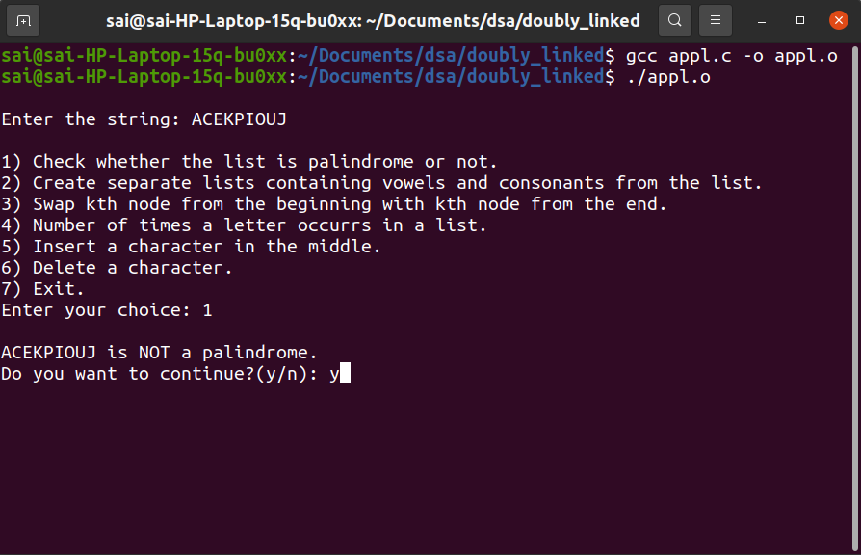

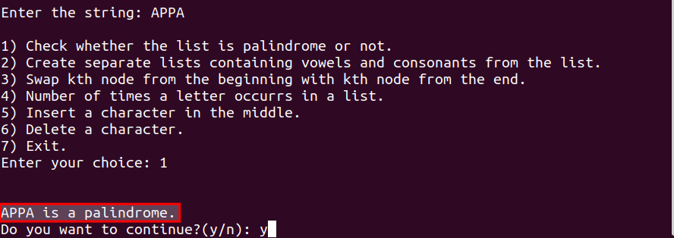

2)Create separate list containing vowels and consonants.

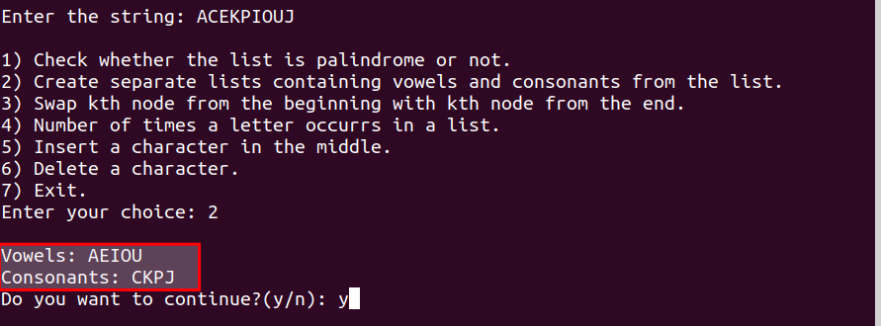
3) Swap kth node from beginning with kth node from end
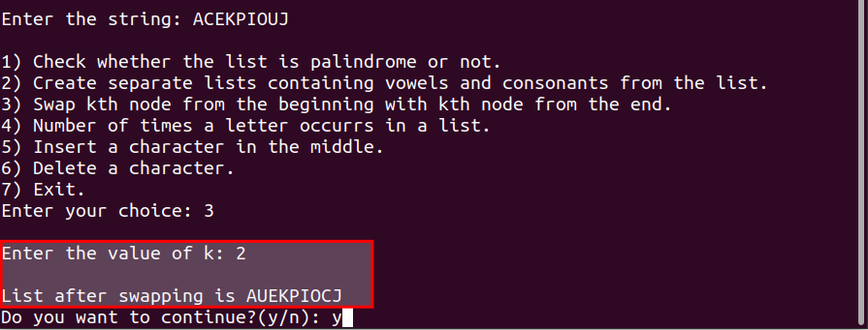
4) Number of times a letter occurrs in a list
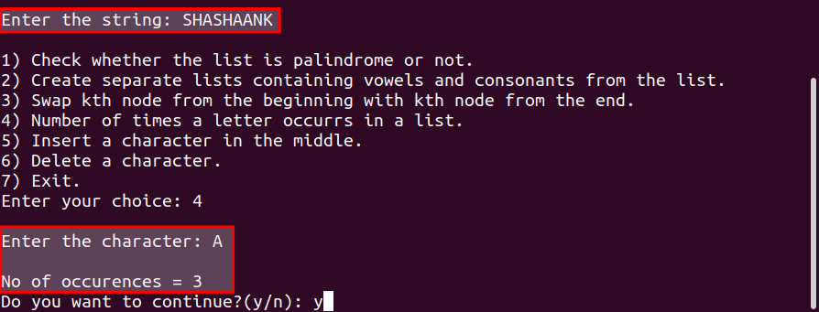

5) Insert a character in the middle
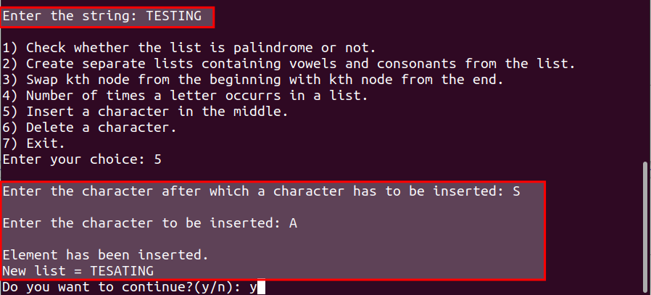
6) Delete a character
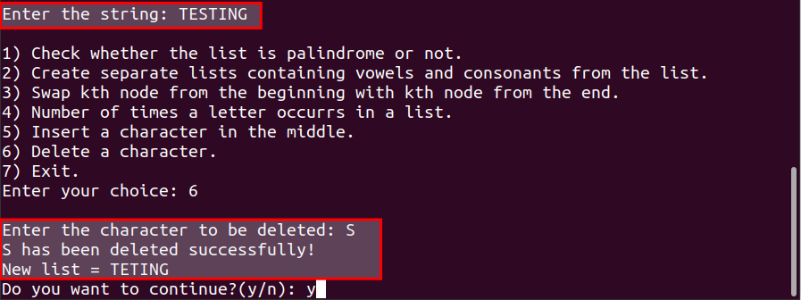
7) Exit
